**PROGRAMMING ASSIGNMENT 2**

**DECISION TREES**

By

Thota, Sai Abhishek – SXT210056

Gauri, Rahul – RXG200002

Part 1 – Learning Curves

We have implemented the learning curves of Monks Dataset using Decision Tree algorithm and we have obtained the three learning curves for Monks 1, Monks 2 and Monks 3 datasets. We have the training examples plotted in red and the testing examples plotted in blue for each of the 3 monks training sets.

Part 2 – Weak Learners

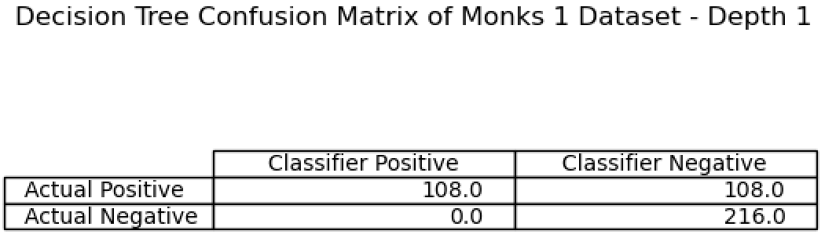

Part 3 – scikit-learn

The above confusion matrix is the confusion matrix generated by scikit-learn tree and preprocessing.

The decision tree using scikit-learn has been visualized using Graphviz and the decision tree has been saved in Monks.pdf.

Part 4 – Using megaGymset.csv dataset

We have generated Confusion Matrix of megaGymset.csv using our implementation of Decision Tree algorithm.

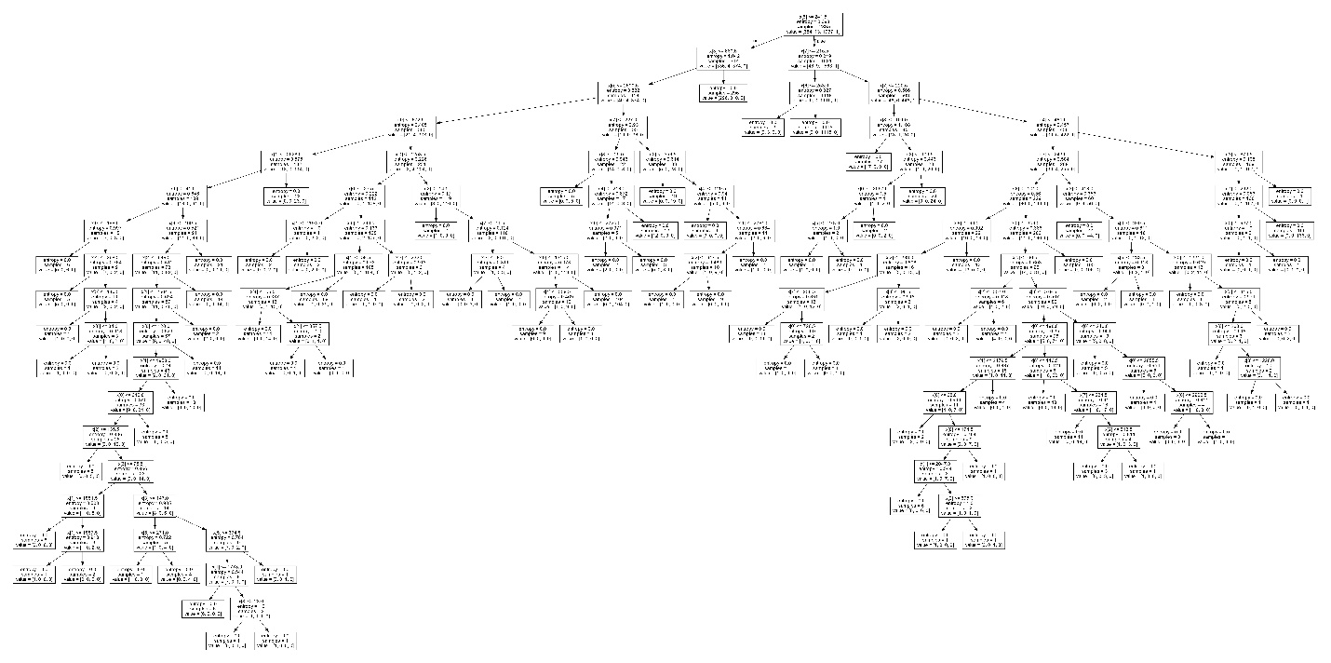

We have designed the Confusion Matrix of megaGymset.csv using scikit-learn tree and preprocessing modules.

The decision tree has been visualized using Graphviz and the decision tree has been saved in Mega Gymset.